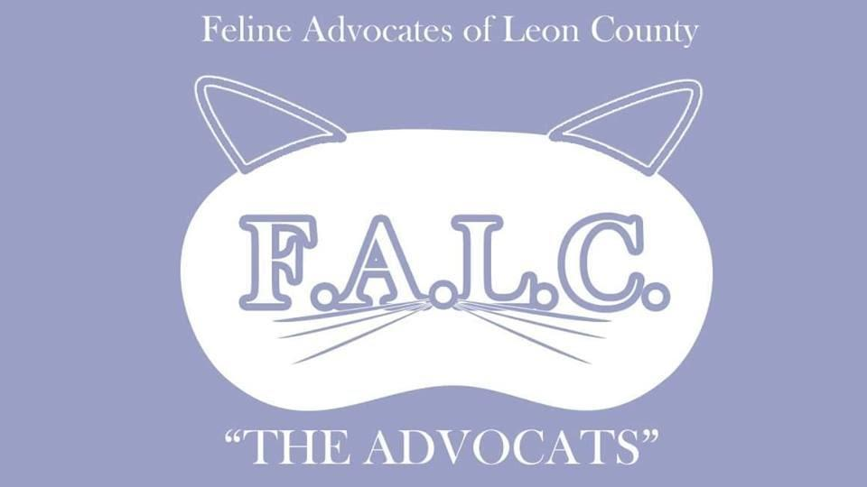
Foster Application & Agreement

Name: _______________________________________ Phone Number: _________________________
Date of Birth: __________________ At least 18 years old? ____
Email Address: ______________________________________________
Physical Address: ____________________________________________ ___________________________________________________________
_____________________________________________________________________________________
First/last names(s) & Age(s) of all other members in household: ________________________________
_____________________________________________________________________________________
Do you own your home? ____________
If renting, please give the name and phone number of your apartment complex/ landlord so we can ensure foster home is pet-friendly: ________________________________________________________
Are all members of household aware of and in agreement regarding fostering a cat(s)? _____________
Please list any current pets in your home (species, gender, age): _______________________________
_____________________________________________________________________________________
Are all of your current pets spayed/neutered? _____________________
Are all of your current pets up to date on vaccinations? _____________
Have your current cats (if any) tested negative for Feline Leukemia and FIV? _____________________
Where in your home will the foster cat(s) be housed? (We generally recommend an isolated space, such as a spare bedroom, especially if there are other pets in the home): ________________________
_____________________________________________________________________________________
Briefly describe your previous fostering and/or other animal rescue experience (previous experience is not required to become a foster): _________________________________________________________
____________________________________________________________________________________
Please provide any dates that you know you will not be able to foster/ when you will no longer be able to foster (ie if you have plans to move):________________________________________________
_____________________________________________________________________________________
Please check the type of fostering you would be interested in:
- Newborn kitten(s) (to be bottle fed)
- Mother & kitten(s)
- Fully-weaned kitten(s)
- One cat at a time
- Special medical needs
- Adult cat(s)

I agree to provide my foster cat with a safe, loving home where he/she will have access to clean water, food & litter at all times and will be kept indoors only.
Initials: ____________
I agree to contact FALC foster coordinator, Gisele Poitras, (561) 779-5607, regarding any concerns with my foster cat as soon as they present themselves, and to not seek veterinary care without prior approval. I agree to not administer or give my foster cat any kind of medical attention myself unless instructed to do so.
Initials: ____________
I understand that when fostering a rescued cat, the previous medical history is not always known. I understand that for this reason, FALC cannot always guarantee the health of our animals. Kittens are not always able to be tested for FIV (Feline HIV) and FeLV (Feline Leukemia) prior to admission into our foster program.
Initials: ____________
I understand that FALC is the sole guardian of cats in foster care and that fostered cats must be returned to FALC upon request. I understand that FALC has the right to request fostered cats back at any time for any reason.
Initials: ____________
I understand that if I, as a foster parent, want to adopt any of my foster cats, I must go through the standard FALC adoption process. I also understand that I may not adopt my foster cats out to another home without the consent of FALC.
Initials: ____________
I understand that if I need to leave town while I have foster cats in my care, I will give FALC as much notice as possible so they may have time to find a replacement foster home. I also agree to not leave my foster cats in the care of another party without previous approval from FALC.
Initials: ____________
I understand that upon approval of my application, a FALC representative will contact me to schedule an initial home-visit prior to any cats being placed in my care. I also understand that upon having a cat placed in my care, a FALC representative may request to perform periodic home visits to ensure the welfare of the animal.
Initials: ____________
I agree to contact FALC prior to taking in any new animals (ie. Adoption, foster, etc.) when currently fostering FALC cat(s).
Initials: ____________

By signing this agreement, I acknowledge that FALC is not responsible for injuries caused by my foster cats to any people (including residents and guests in my home), and/or any other animal(s). I also acknowledge that FALC is not responsible for any damages to my home caused by my foster cats. This includes but is not limited to clothing, furniture, and flooring. I certify that all of the information contained within this application is true to the best of my knowledge.

Applicant’s Signature: __________________________________________________________________

Applicant’s Printed Name: _______________________________________________________________

Date: _________________ Approved by FALC BOD: ________________________________
We look forward to having you as a foster! If you have FaceBook, feel free to join our FALC Foster Group. Just search “FALC Fosters” or go to this link: https://www.facebook.com/groups/1386570438444096/

